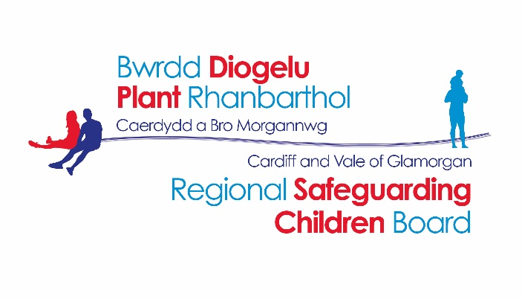
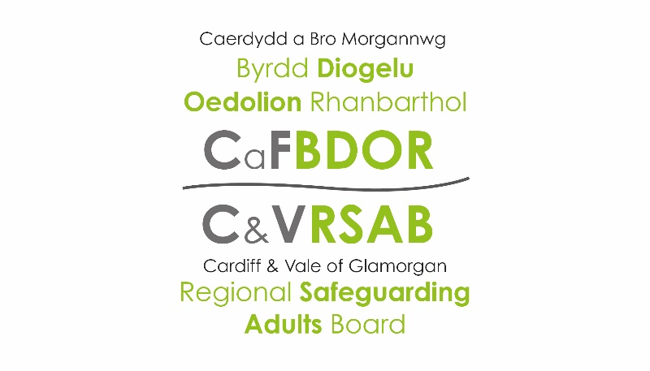

Cardiff & Vale of Glamorgan
Regional Safeguarding Boards

National Safeguarding Week
11th – 15th November 2019

Programme of Events

Monday 11th November 2019
Time | Name of Event & Description | Target audience | Venue | To book/Contact details
12:00 – 16:30 | National Event:  Launch of the Wales Safeguarding Procedures | - Regional Safeguarding Boards and Partners | Temple of Peace, King Edward VII Avenue, Cardiff,  CF10 3AP | Safeguarding Boards Business Unit  cardiffandvalersb@cardiff.gov.uk
08:30 – 16:00 | Information Stands  (Raising awareness around prevention of domestic abuse) | - Open to the public, staff and practitioners | Concourse, University Hospital of Wales, Cardiff | Open Event

Tuesday 12th November 2019
Time | Name of Event & Description | Target audience | Venue | To book/Contact details
9:30 – 16:00 | Crime Prevention & Safety Awareness Roadshow / Information Stands  (To raise awareness of scams, swindles, personal safety, security of personal property, knife crime and domestic abuse etc). | - Students, staff and members of the public. | Viriamu Jones Gallery, Main Foyer, Cardiff University, Main Building, Park Place, CF10 3AT | William Farnham,  Cardiff Neighbourhood Watch  William.Farnham@south-wales.pnn.police.uk  OR  Safeguarding Boards Business Unit  cardiffandvalersb@cardiff.gov.uk
13:30 – 14:30 | NSPCC Workshop: Working with Children who have Experienced Trauma  (To demonstrate how NSPCC staff can support children/young people and their families who have experienced trauma. Trauma being the experience of an event by a child or young person that is emotionally painful or distressing, which can result in lasting emotional and or physical effects. We will explore how trauma informed practice can support children and promote safeguarding) | - Practitioners and members of the public  (social works, teachers, nursery staff and members of the public) | NSPCC Offices, Diane Engelhardt House, Unit 2, Treglown Court, Dowlais Road, Cardiff, CF24 5LQ | Fiona Stevens  02920108080
15:00 – 16:00 | NSPCC Workshop: Working with Children who have Experienced Trauma | - Practitioners and members of the public  (social works, teachers, nursery staff and members of the public) | NSPCC Offices, Diane Engelhardt House, Unit 2, Treglown Court, Dowlais Road, Cardiff, CF24 5LQ | Fiona Stevens  02920108080

Wednesday 13th November 2019
Time | Name of Event & Description | Target audience | Venue | To book/Contact details
10:00 – 14:00 | Young People’s Conference | - Children from years 7, 8 & 9 from Secondary Schools in Cardiff & Vale of Glamorgan | Motorpoint Arena, Cardiff, CF10 2EQ | Safeguarding Education reps from Cardiff & Vale
9:30 – 15.30 | Crime Prevention & Safety Awareness Roadshow / Information stands  (To raise awareness of scams, swindles, personal safety, security of personal property, knife crime and domestic abuse etc). | - Students, staff and members of the public. | School of Management Building, Cardiff Metropolitan University, Llandaff Campus, Western Avenue,  CF5 2YB | William Farnham,  Cardiff Neighbourhood Watch  William.Farnham@south-wales.pnn.police.uk  OR  Safeguarding Boards Business Unit  cardiffandvalersb@cardiff.gov.uk

Thursday 14th November 2019

Time | Name of Event & Description | Target audience | Venue | To book/Contact details
9.00 – 13:00 | Domestic Abuse Workshop | - Practitioners | Memo Centre, Gladstone Road, Barry, CF62 8NA | Safeguarding Boards Business Unit  cardiffandvalersb@cardiff.gov.uk
11:00 – 14:00 | Crime Prevention & Safety Awareness Roadshow  (To advise people to be aware of scams, cold callers, personal safety, home security, car theft etc). | - Students, staff and members of the public | Drawing Room, Insole Court, Llandaff, Cardiff, CF5 2LN | William Farnham,  Cardiff Neighbourhood Watch  William.Farnham@south-wales.pnn.police.uk
14:00 – 16:30 | Presentation on County Lines/Cuckooing | - The Older People’s Groups/Sheltered Schemes and Residents | Golau Caredig, Gladstone Road, Barry, CF62 7AZ | Safeguarding Boards Business Unit  cardiffandvalersb@cardiff.gov.uk
18:00 | Presentation on Domestic Abuse, Exploitation and Gang Culture.  (The event will look at the different forms of domestic abuse, exploitation and gang culture and will also feature the ‘Fearless’ Video and the White Ribbon Project) | - Primarily Neighbourhood Watch Coordinators (but also open to anyone else who may be interested) | Civic Centre, Holton Road, Barry, CF63 4RU | Stacey Evans, Safer Vale Partnership  01446 450200  safervale@south-wales.pnn.police.uk

Monday 25th November 2019
Time | Name of Event & Description | Target audience | Venue | To book/Contact details
13:45 – 17:00  17:00 | International Day for the Elimination of Violence Against Women and White Ribbon Day:  - Cross-Party Stakeholder Event  - Candlelight Vigil | - Practitioners | Senedd, Pierhead Street, Cardiff Bay, CF99 1NA | walesoffice@nfwi-wales.org.uk
08:30 – 16:00 | Information Stands  (Raising awareness around prevention of domestic abuse) | - Open to the public and staff | Concourse, University Hospital of Wales, Cardiff | Open Event
Friday 15th November 2019

Time | Name of Event & Description | Target audience | Venue | To book/Contact details
9:00 – 13:00 | Professionals Conference | - Practitioners | Memo Centre, Gladstone Road, Barry, CF62 8NA | Safeguarding Boards Business Unit  cardiffandvalersb@cardiff.gov.uk
18:30 | Safeguarding Awards Evening | - Practitioners  - 3rd Sector Employees  - Volunteers  - Members of the Community e.g. Foster Carers, Campaigners | Whitchurch Rugby Club, Samuels Crescent, Cardiff, CF 14 2TH | Safeguarding Boards Business Unit  cardiffandvalersb@cardiff.gov.uk

