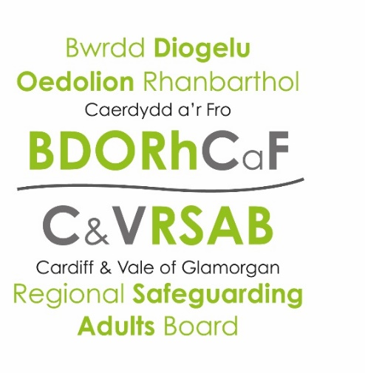
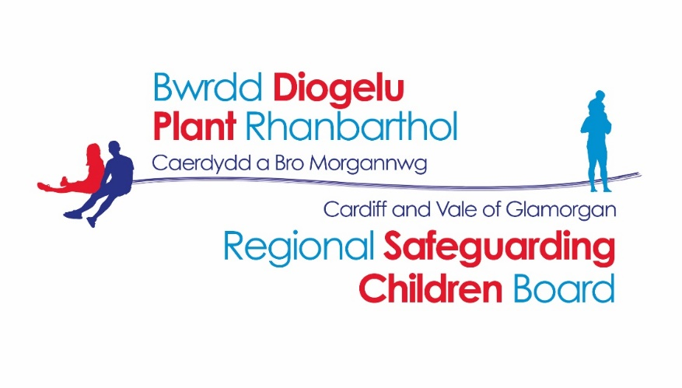

CARDIFF AND VALE OF GLAMORGAN REGIONAL SAFEGUARDING BOARDs
ANNUAL PLAN
2019 – 2020

CONTENTS
 | Page
INTRODUCTION  OUR MISSION STATEMENT | 3
WHAT IS SAFEGUARDING? | 4  4-5
WHAT IS A SAFEGUARDING BOARD?
MEMBERSHIP | 6-9
STRUCTURE | 10
PRIORITY AREAS FOR 2018/2019 | 11
PRIORITY 1 | 12-14
PRIORITY 2 | 15
PRIORITY 3 | 16
BOARD BUDGET | 17
CONTACT US | 18

INTRODUCTION
This Annual Plan sets outs the strategic priorities, key actions, milestones and performance measures, along with the responsible partners and structure for the period April 2019 to March 2020. It takes into account both the current requirements placed on Safeguarding Children Boards and Safeguarding Adult Boards by Welsh Government and the statutory guidance in relation to Part 7 of the Social Services and Well-being (Wales) Act 2014. Under that guidance, Safeguarding Boards are required to produce annual plans, to be published prior to the beginning of each financial year, and to produce and publish an annual report each July evidencing progress made against the previous year’s Annual Plan. The Act, supplemented by the regulations, provides for when and how the annual plans and reports are to be published and prescribes the content of both the annual plans and the annual reports.
This document is available in Welsh / Mae’r ddogfen hon ar gael yn Gymraeg.

OUR MISSION STATEMENT
Cardiff and Vale of Glamorgan Regional Safeguarding Children Board will ensure that effective arrangements are in place to protect children within the region who are at risk of abuse, neglect or exploitation.
Cardiff and Vale of Glamorgan Regional Safeguarding Adults Board will protect adults within its area who have needs for care and support (whether or not a local authority is meeting any of those needs) and are experiencing, or are at risk of, abuse or neglect. The Board will aim to prevent those adults within its area, from becoming at risk of abuse, neglect or other kinds of harm and will provide the overall responsibility for challenging agencies to ensure effective measures are in place to protect and prevent.
To achieve these aims the Boards will:
- Promote the development of strategies to prevent risk effectively
- Ensure that agencies are able to challenge themselves and partners in delivering their individual and shared accountability for safeguarding effectively
- Ensure that the voice of the person is heard and recognised in its deliberations
- Promote a culture of critical analysis and review to ensure that lessons are learned when people suffer harm because of gaps in policy, systems or practice

WHAT IS SAFEGUARDING?
Safeguarding is about protecting children and adults from abuse or neglect. Everyone has a responsibility for safeguarding. Everyone should be protected from being hurt, put at risk of harm or abused, regardless of their age, gender, religion or ethnicity.
Abuse
Abuse is when someone does or says things to another person to hurt, upset or make them frightened. It can consist of single or repeated acts.
The abuse can be committed by anyone, but is usually from someone who is in a position of trust – a relative, friend, paid worker or volunteer.
Abuse can take many forms
- Physical (hitting, kicking, undue restraint, over or misuse of medication, or inappropriate sanctions).
- Psychological / emotional (threats of harm or humiliation, controlling relationships and isolation, verbal or racial abuse).
- Sexual (unwanted sexual activity which the adult at risk has not consented to/and or was pressured into consenting).
- Financial (theft, fraud or applying pressure around property or wills).
- Neglect (failure to meet the everyday needs of the individual at risk, failure to access medical care or services or failure to give prescribed medication).

WHAT IS A SAFEGUARDING CHILDREN BOARD?
The Cardiff and the Vale of Glamorgan Regional Safeguarding Children Board (RSCB) brings together representatives of each of the main agencies and professionals responsible for safeguarding children in our region.

As outlined in the Social Services and Well-being (Wales) Act 2014 – Working Together to Safeguard People guidance, the objectives of a Safeguarding Children Board are:
- to protect children within its area who are experiencing, or are at risk of abuse, neglect or other kinds of harm, and
- to prevent children within its area from becoming at risk of abuse, neglect or other kinds of harm.
In order to meet these objectives a Safeguarding Board has a number of functions that can be found in the Social Services and Well-being (Wales) Act 2014 – Working Together to Safeguard People: Volume 1 – Introduction and Overview.

WHAT IS A SAFEGUARDING ADULTS BOARD?
Cardiff and Vale of Glamorgan Regional Safeguarding Adults Board (C&V RSAB) is a multi-agency partnership comprising of statutory, independent and charitable organisations who work together to safeguard adults from abuse.
The role of the Board is to ensure the effective coordination of services to safeguard and promote the welfare of local adults who may be at risk of abuse and neglect within the Cardiff and Vale of Glamorgan area.
The Board aims to promote awareness and understanding of abuse and neglect among service users, carers, professionals, care providers and the wider community and works to generate community interest and engagement to ensure that Safeguarding is “Everyone’s Business”.
The main objectives of the Board, as outlined in the Social Services & Wellbeing (Wales) Act 2014 are:
- to protect adults within its area who have needs for care and support (whether or not a local authority is meeting any of those needs) and are experiencing, or are at risk of, abuse or neglect
- to prevent those adults within its area mentioned above, from becoming at risk of abuse or neglect

MEMBERSHIP OF CARDIFF AND VALE OF GLAMORGAN SAFEGUARDING CHILDREN BOARD
The membership complies with the guidance issued under Part 7 (Section 134(2) of the SS&WB Act 2014). A list of members is below:

Name | Position
Local Authority
Claire Marchant CO-CHAIR | Director of Social Services, Cardiff
Lance Carver CO-CHAIR | Director of Social Services, Vale of Glamorgan
Deborah Driffield | Assistant Director of Children’s Services, Cardiff
Rachel Evans | Head of Service for Children and Young People Services, Vale of Glamorgan
Alys Jones | Operational Manager of Safeguarding and Review, Cardiff
Natasha James | Operational Manager of Safeguarding and Service Outcomes, Vale of Glamorgan
Health Board
Jason Roberts | Deputy Executive Director of Nursing, Cardiff and Vale University Health Board
Linda Hughes-Jones | Head of Safeguarding, Cardiff and Vale University Health Board
Katina Kontos | Named Doctor safeguarding Children, Cardiff and Vale University Health Board
Ruth Walker | Executive Nurse Director, Cardiff and Vale University Health Board
Velindre NHS Trust
Jayne Elias | Assistant Director of Nursing & Service Improvement, Velindre NHS Trust
Susan Morgan | Executive Director of Nursing & Service Improvement, Velindre NHS Trust
South Wales Police
Stephen Murray | Superintendent for Eastern BCU, South Wales Police
Claire Evans | Superintendent, Central BCU, South Wales Police
Beth Aynsley | Independent Protecting Vulnerable Person Manager, South Wales Police
National Probation Service
Hannah Williams | LDU Head for National Probation Service
Jane Foulner | Senior Probation Officer for National Probation Service
Community Rehabilitation Company
Victoria Harris | LDU Head for Wales Community Rehabilitation Company
Education
TBC | Assistant Director of Education and Lifelong Learning, Cardiff
David Davies | Head of Achievement for All for School Improvement & Inclusion, Vale of Glamorgan
Deborah Herald | Acting Head Teacher of Riverbank Primary School, Cardiff
Anna Davies | Deputy Head Teacher of Bryn Hafren Comprehensive School, Vale of Glamorgan
National Safeguarding Team, Public Health Wales
Debbie Pachu | Designated Nurse for NHS Wales National Safeguarding Team, Public Health Wales
Alison Mott | Designated Doctor, National Safeguarding Team, Public Health Wales
Visas and Immigration
Kala Smith | Technical Specialist & UASC Lead for UK Visas and Immigration
Rhiannon Chatterton | Head of Asylum for UK Visas and Immigration
Housing
Pam Toms | Operational Manager of Housing Services, Vale of Glamorgan
Jane Thomas | Assistant Director, Housing & Communities, Cardiff
Youth Offending Service
Paula Barnett | YOS Manager for Children and Young People Services, Vale of Glamorgan
Kate Hustler | YOS Manager for Children and Young People Services, Cardiff
Welsh Ambulance Service NHS Trust
Nikki Harvey | Head of Safeguarding for WAST
Third Sector
Tracy Holdsworth | Service Manager, NSPCC
Emma Phipps Magill | Service Manager, NYAS
Liz Baker | Assistant Director, Barnardo’s
Morgan Fackrell | Chief Executive of Cardiff Women’s Aid
Advisors in Attendance
Sheila Davies | Operational Manager for Legal & Democratic Services, Community Team Legal, Cardiff

MEMBERSHIP OF REGIONAL SAFEGUARDING ADULTS BOARD
The membership complies with the guidance issued under Part 7 (Section 134(2) of the SS&WB Act 2014). A list of members is below:

Name | Position
Local Authority
Lance Carver  CO-CHAIR | Director of Social Services, Vale of Glamorgan
Claire Marchant  CO-CHAIR | Director of Social Services, Cardiff
Amanda Phillips | Head of Resources and Safeguarding, Vale of Glamorgan
Suzanne Clifton | Head of Service for Adults, Vale of Glamorgan
Louise Barry | Assistant Director of Adult Services, Cardiff
Alys Jones | Operational Manager of Safeguarding and Review, Cardiff
Natasha James | Operational Manager of Safeguarding & Service Outcomes, Vale of Glamorgan
Health Board
Ruth Walker | Executive Nurse Director, Cardiff and Vale University Health Board
Jason Roberts | Deputy Executive Director of Nursing, Cardiff and Vale University Health Board
Linda Hughes-Jones | Head of Safeguarding, Cardiff and Vale University Health Board
Suzanne Wood | Consultant, Cardiff & Vale Public Health Medicine
Jodie Dennis | Lead Nurse, Abertawe Bro Morgannwg Health Board
Velindre NHS Trust
Jayne Elias | Deputy Director of Nursing & Service Improvement, Velindre NHS Trust
National Safeguarding Team, Public Health
Debbie Pachu | Designated Nurse for NHS Wales National Safeguarding Team, Public Health Wales
South Wales Police
Claire Evans | Superintendent, Central BCU, South Wales Police
Steve Murray | Superintendent, Eastern BCU, South Wales Police
Beth Aynsley | Independent Protecting Vulnerable Person Manager, South Wales Police
National Probation Service
Hannah Williams | LDU Head for National Probation Service
Community Rehabilitation Company
Victoria Harris | LDU Head for Wales Community Rehabilitation Company
HMP Cardiff
Helen Ryder | Governor
Welsh Ambulance Service Trust
Nikki Harvey | Named Professional for Safeguarding
South Wales Fire and Rescue
Shaun Moody | Group Manager Community Safety and Partnerships
Third Sector
Sandra Roberts | Vale Centre for Voluntary Services
Rachael Nicholson-Wright | Director of Action on Elder Abuse Cymru
Care Providers
Brian West | Chair of Vale of Glamorgan Care Homes/Care Forum Wales
Mandy Evans | Learning Disability & Supported Living Care Providers
Advisors in Attendance
Carolyn Goodall | Senior Lawyer, Legal Services, Vale of Glamorgan Council

Additional representatives form the following Sub Groups:
- CPR/APR Practice Review Sub Group
- Training Sub Group
- Audit Sub Group
- Communication and Engagement Sub Group
- Policies, Procedures and Protocol Sub Group
- Thematic Strategic Group
- Task and Finish Groups (as required)

STRUCTURE
Regional Safeguarding Adult/Children Boards
Safeguarding Adults Business Planning
Group
Joint
Policies, Procedures and Protocols Sub Group
Joint
Communication and Engagement Sub Group
Joint
Training
Sub Group
Children’s Audit
Sub Group
Adult’s Audit
Sub Group
CPR/APR
Panels
Safeguarding Children Business Planning Group
Task and Finish Groups (as required)
Joint
CPR/APR
Sub Group
Children’s Thematic Group
Adult’s Thematic Group

PRIORITY AREAS FOR 2019/2020
The four overarching priority areas of Cardiff and Vale of Glamorgan RSCB for 2019/2020 are:

Priority 1 | Workforce and Practice
Priority 2 | Rights, Values and Voice of the Person
Priority 3 | Independent Provider Sector

How we intend to achieve these priorities is listed in our business plan below.
PRINCIPLES:
All priorities are in respect of the safeguarding process, unless stated otherwise.
All priorities are in respect of both safeguarding Children and Adults, unless stated otherwise.

Priority 1 – Workforce and Practice
Outcome: People are safer as a consequence of the workforce being supported, skilled, capable and knowledgeable, in order to effectively safeguard children and adults in the region

Objective: The board have assurances that there is effective inter-agency safeguarding practices, which are supported by policies and procedures, with robust multi-agency training.

No. | Actions needed | Timeline | Responsible
1 | Put mechanisms in place for multi-agency training to be developed and facilitated.  Develop a multi-agency training and information strategy:  - Ensure that multi-agency training is available to develop skills, resilience and confidence amongst the workforce.  - Develop a reciprocal training agreement between partner agencies  - Publish a joint training programme on the Board website  - Board partners commit to providing Practice Forums facilitated by identified partner agencies  - Dissemination of research, good practice and policy updates are co-ordinated to reach intended audiences to ensure knowledge base of practitioners is maintained and developed | March 2020  June 2019 | RSB Training Sub Group and Regional Workforce Partnership Board  Training Sub-Group and Communication & Engagement Sub-Group  Alys Jones (Operational Manager for Safeguarding and Review, Cardiff)  Natasha James (Operational Manager for Safeguarding and Service Outcomes, Vale of Glamorgan)
2 | Disseminate lessons learned from Child Practice Reviews and Adult Practice Reviews amongst professionals from across the region to develop an understanding and awareness of the themes and trends that are prevalent within safeguarding practice.  - Ensure all agencies are accountable for their participation in an effective review system through the creation of a multi-agency accountability framework  - The Board establishes effective systems for monitoring, holding to account and evaluating the impact of lessons from reviews. | Sept 2019 | Alys Jones (Operational Manager for Safeguarding and Review, Cardiff)  Natasha James (Operational Manager for Safeguarding and Service Outcomes, Vale of Glamorgan)  Steve Murray (Superintendent, Eastern BCU, South Wales Police)  CPR/APR Sub Group, Amanda Phillips (Head of Resources and Safeguarding, Vale of Glamorgan)
3 | Use a range of intelligence data information to understand strengths and challenges of our safeguarding systems to support continuous improvement.  - Understanding and establishing a baseline of performance information for safeguarding, by:  - interrogating the data sets used by other boards  - Creating a QA framework for Board  - Develop a suite of performance indicators that feed into the Annual Report.  - Agree a systematic approach to capturing and promoting good practice and ensuring improvements are addressed  - Set a baseline regarding the active offer of advocacy and monitor. | March 2020 | Alys Jones (Operational Manager for Safeguarding and Review, Cardiff)  Natasha James (Operational Manager for Safeguarding and Service Outcomes, Vale of Glamorgan)  Safeguarding Business Unit Manager  Adult Audit Sub-Group
4 | Implement the new All Wales Safeguarding Procedures ensuring local understanding and consistency  To have agreed screening, evaluation and decision making policies for Cardiff and Vale Regional Safeguarding Boards and all organisations within.  - Develop the document in a Task & Finish Group  - Seek agreement for document and plan implementation  - Training  - Audit plan put in place | From October 2019  March 2020 | All  Policies, Procedures and Protocols Sub-Group via Task & Finish Group  Children’s – Task and Finish Group to be led by Liz Baker, Barnardos  Adult’s – Task and Finish Group led Amanda Phillips & Louise Barry
5 | Effectively implement the exploitation strategy and take forward priority actions throughout the year. | Implement by June 2019 | Joint Exploitation Thematic Group and Joint Training Sub-group
6 | Review if there is effective inter-agency safeguarding practice around homelessness | Presentation on homelessness and safeguarding to Board in June 2019 | Louise Barry/ Jane Thomas  Mike Ingram/Pam Toms

Priority 2 – Rights, Values and Voice of the Person
Outcome: Children, and adults who have care and support needs, feel heard and empowered within a safeguarding process

Objective: To embed a rights based approach throughout the safeguarding system from individual practice to the work of the safeguarding board and everything in between

No. | Actions needed |  | Timeline | Responsible
1 | Commission an expert organisation to scope current practices regarding the voice of the adult in relation to the safeguarding process, including the adult protection conferences  *Adults |  | Sept 2019, report by Dec 2019 | Communication and Engagement Sub Group
2 | Map out stakeholder engagement and consultation processes in relation to existing user networks.  Identify existing user networks that can be utilised to develop an ‘expert by experience’ advisory group. |  | Sept 2019  Dec 2019 | Communication and Engagement Sub Group
3 | Agree and implement recommendations from the NYAS report |  | April 2019 | Regional Safeguarding Board
4 | Ensure Child Protection processes take into account the lived experience of the child. |  | Sept 2019 | Children’s Audit Sub-Group
Priority 3 – Independent Provider Sector
Outcome: Assurance that the quality of care at home and in care homes is of a high standard
Objective: Consistent and robust quality assurances across the region to inform safeguarding practice

No. | Actions needed |  | Timeline | Responsible
1 | Align the two local authority protocols and adopt a RSB wide single provider performance protocol thus ensuring a consistent and robust Quality Assurance approach across the board’s area *Adults |  | June 2019 | Louise Barry (Assistant Director for Adult Services, Cardiff)  Amanda Phillips (Head of Resources and Safeguarding, Vale of Glamorgan)
2 | Implement the Joint Escalating Concerns Procedure and present an overview of escalating concerns activity to the Board quarterly as a standing agenda action *Adults |  | From June 2019 | Amanda Phillips (Head of Resources and Safeguarding, Vale of Glamorgan)  Louise Barry (Assistant Director for Adult Services, Cardiff)
3 | Explore how the quality and availability of care and support services for children can be improved across the region from a safeguarding perspective  *Children |  | June 2019 | Deborah Driffield  Rachel Evans
4 | Develop a regional Joint Escalating Concerns protocol for children |  | By September 2019 | Angela Bourge  Amanda Phillips

BOARD BUDGET

Organisation | Proposed  Contribution Combined  (%) | Organisation Split | Current Contribution to RSCB Split  (%) | Proposed  Contribution Split  (£)
Local Authorities | 60% | Cardiff Council | 67% | £60,000.00
 |  | Vale of Glamorgan Council | 33% | £30,000.00
SWP | 10% | South Wales Police | 100% | £15,000.00
Health | 25% | Cardiff and Vale UHB | 81.25% | £30,468.75
 |  | Velindre NHS | 18.75% | £7,031.25
Probation | 5% | Wales CRC | 50% | £3,750.00
 |  | NOMS | 50% | £3,750.00
TOTAL | 100% |  |  | £150,000

CONTACT US:
Please contact the Safeguarding Business Unit for any additional information/guidance via the following avenues:
Address:
Cardiff and Vale Regional Safeguarding Boards Business Unit
Room 342
County Hall
Cardiff
CF10 4UW
(02920) 871891
Email: CardiffandValeRSB@cardiff.gov.uk

